***Login Page on starting the Program***

Username: admin

Password: admin 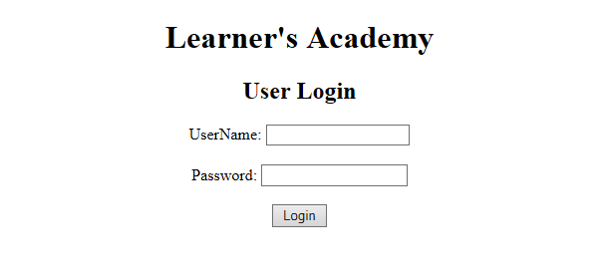

If the credentials gone wrong:

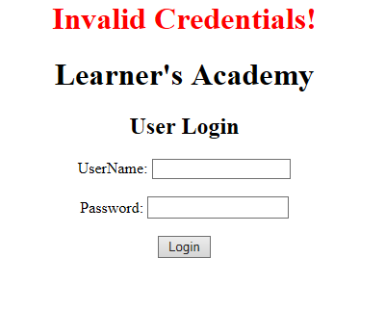

After Login with correct credentials:

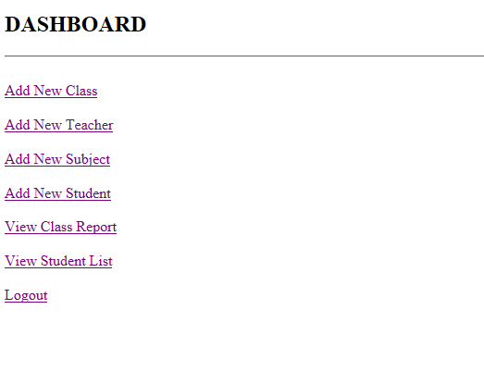

Result after selecting each and every option.

After Selecting Add New Class

After Selecting Add New Teacher

After Selecting Add New Subject

After Selecting Add New Student

After Selecting View Student List

After Selecting Add New Class

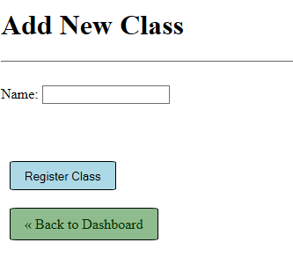

It only ask for Name of the class.

Suppose I want to register my new Class A

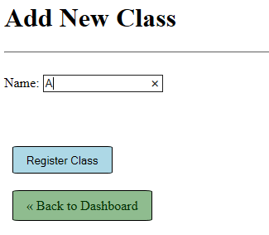

After Clicking on register class it add the Class A to database. If the class with same name is present it will not add the class.

After Selecting Add New Teacher

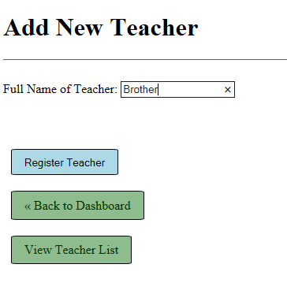

It only take Full name of teacher as parameter.

By clicking on register Teacher, it registers the Teacher.

After Clicking on View Teacher List.

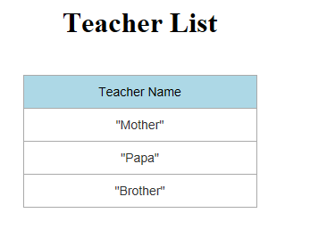

After Selecting Add New Subject

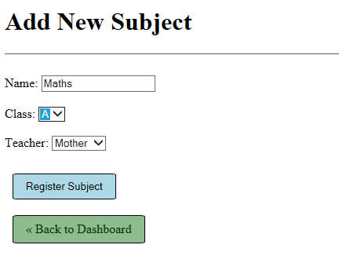

It takes 3 Parameters:

* Subject Name
* Class to which Subject is to mapped
* Teacher who will teach the subject.

There is drop down list for Class and Teacher from which you could select the present teacher and class for the subject.

After Selecting Add New Student

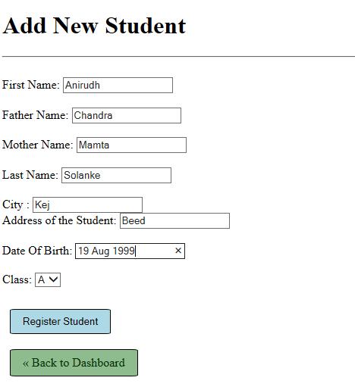

**Note:** The Date of birth format must be DD-MMM-YYYY.

After selecting View Student List

